
RAMAIAH
INSTITUTE OF TECHNOLOGY
USN | 1 | M | S

(Autonomous Institute, Affiliated to VTU)
Bangalore – 560 054

SEMESTER END EXAMINATIONS – JANUARY 2017

Course & Branch | : | B.E: Common to all Branches | Semester | : | I/II
Subject | : | Basic Civil Engineering and Mechanics | Max. Marks | : | 100
Subject Code | : | CV101/201 | Duration | : | 3 Hrs

Instructions to the Candidates:
- Answer one full question from each unit.

 |  | UNIT - I
1. | a) | Identify the Fields of Civil Engineers when  i) There exists scarcity of water  ii) Problems encountered in drinking water.  iii) Design of Runway is required for Aero plane.  Briefly explain each of these fields of Civil Engineering. | CO1 | (12)
 | b) | Explain the properties of these materials and their applications:  i) Bricks ii) Timber. | CO1 | (08)
2. | a) | Explain the societal impact of Civil Engineering fields in the socio economic development of the country? | CO1 | (12)
 | b) | Justify the difference of these materials with respect to their properties  i)Plain concrete and Reinforced concrete  ii)RCC and PSC | CO1 | (08)
 |  | UNIT - II
3. | a) | Define the following terms.  i) Rigid body ii) Couple iii) Resultant iv) Equilibrant v) Equivalent force couple system. | CO2 | (10)
 | b) | If the resultant of the two forces shown in Fig 3b is 700 N directed vertically upwards, find the angles α and β using rectangular components.  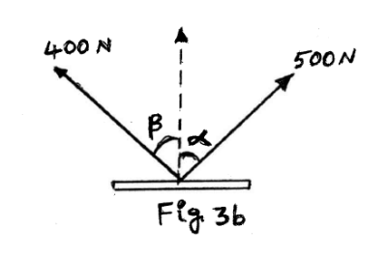 | CO2 | (10)
4. | a) | State and prove varignon’s theorem. | CO2 | (08)
 | b) | Find the resultant of the force system acting on a body OABC as shown in Fig 4b. Also find the points where the resultant will cut the X and Y axis.  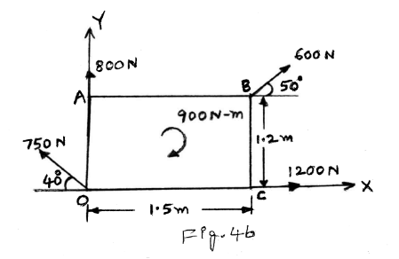 | CO2 | (12)
 |  | UNIT - III
5. | a) | Determine the angle ϴfor the system of strings ABCD in equilibrium. Also determine the tension in different segments of the string.  Figure-5a  ϴ  D  C  B  A  30◦  60◦  25N  20N | CO3 | (10)
 | b) | Cylinder A of diameter 200mm and cylinder B of diameter 300mm are placed in a trough as shown in figure(5.b).If cylinder A weighs 800N and cylinder B weighs 1200N. Determine the reactions developed at contact points P,Q,R and S. Assume all contact surfaces as smooth?  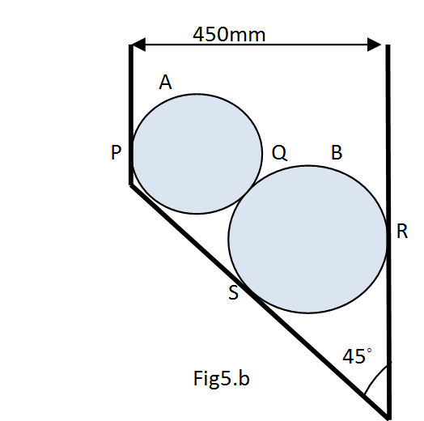 | CO3 | (10)
6. | a) | Find the support reaction at A and B for the beam shown in the figure.  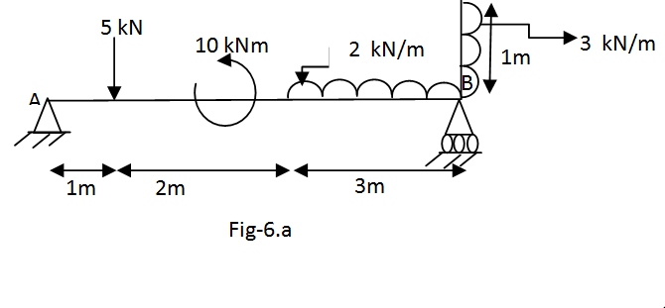 | CO3 | (12)
 | b) | Represent with neat sketches:  - Types of Loads  - Types of beams. | CO3 | (08)
 |  | UNIT - IV
7. | a) | Define the following terms:  i) Centroid ii) Axis of symmetry. | CO4 | (04)
 | b) | Derive the co-ordinates of Centroid of a quadrant from first principles. | CO4 | (06)
 | c) | Locate the Centroid of the shaded portion of a lamina as shown in Fig 7c, if AB= 90 mm is diameter of semicircle.  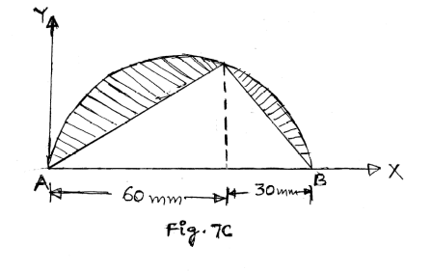 | CO4 | (10)
8. | a) | State and prove parallel axis theorems of moment of inertia. | CO4 | (06)
 | b) | For the shaded area shown in Fig 8b, determine the moment of inertia and radius of gyration about the horizontal and vertical centroidal axes. Also calculate the radius of gyration about the same axes.  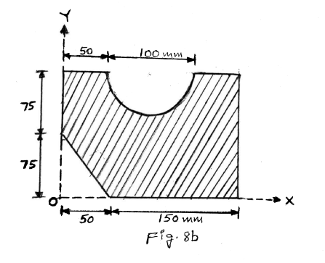 | CO4 | (14)
 |  | UNIT – V
9. | a) | Define different types of friction. Also write the laws of static friction. | CO5 | (10)
 | b) | What is the minimum value of force P to cause impending motion towards right for the block 200 N (Fig.9.b). Assume coefficient of friction μ=0.2 for all contact surfaces.  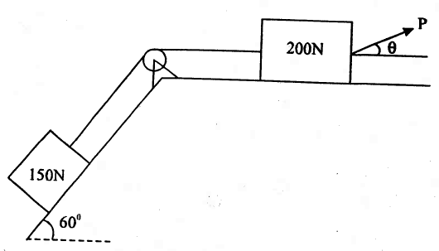  Fig.9.b | CO5 | (10)
10. | a) | Define the following terms.  - Angle of friction. (ii) Coefficient of friction. | CO5 | (05)
 | b) | A ladder 5 m long and 300 N weight is placed against a vertical wall in a position where its inclination to the vertical wall is 30⁰ (Fig 10.b). A man weighing 700 N climbs the ladder. At what position will be induce slipping? The coefficient of friction μ=0.25 for all contact surfaces.  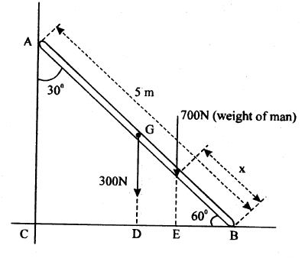  Fig 10.b | CO5 | (07)
 | c) | For the wedge arrangement shown in Fig 10.c, if P=1200 N, calculate the force Q to be placed on the weightless wedge B so that it is on the verge of moving upward under the action of the force P. Given μ=0.25 at floor and 0.33 at contact surface of wedge.  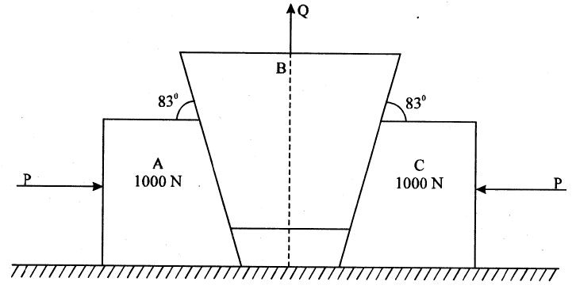  Fig.10.c | CO5 | (08)

****************

